IT1060 – Software Process Modeling February, September, July - 2024 - 2023

Assignment 2 Cover Sheet

CASE STUDY NAME | Online customer support system
PROJECT ID | MLB_04.02_07

Group Details:

 | Student Registration Number | Student Name
1 | IT23631410 | B G S H Dilshara
2 | IT23588714 | K H S Dinsara
3 | IT23775442 | T G C Theekshana
4 | IT23656574 | G H C R Saumya
5 | IT23637832 | D D Samaranayaka

Assignment 2 Certify Sheet


I

hereby

certify,

The

attached

is

my

own

work

and

no

further

changes

will

be

made.

I

have

contributed

in this assignment

to

the best

of

my ability.

And

I

understand,

I

may

be

subject

to

student

discipline

processes

in

the

event

of

an

act

of

academic

misconduct

by

me

including

an

act of

plagiarism

or

cheating.

Student Details:

Student Name | Student Registration Number | Date | Signature
K.H.S.Dinsara | IT23588714 | 06/10/2024

K.H.S.Dinsara – IT23588714

Part 01 – Use Case Scenario

Use case ID | 01
Use case Name | Create user account
Summary | Register as a user
Priority | 02
Pre-condition | Search and visit website
Post-condition | The system sent a verification link to the user’s email
Primary actor | Guest
Trigger | User is chosen to register the system.
Main scenario | Step | Action
 | (1) | Search website.
 | (2) | Click on the home page.
 | (3) | Click on the sign-up button.
 | (4) | Display registration form.
 | (5) | Enter the username, email, password and re-enter the password.
 | (6) | Click on the submit button.
 | (7) | Check the email for a verification link.
 | (8) | Click on the verification link.
 | (9) | Verify email address.
 | (10) | The system displays registration successfully.
Extensions | Step | Branching Action
 | (5a) | The system notifies email of invalid.
 | (5b) | The system notifies the username already exists.
 | (5c) | The system notifies the password is weak.
 | (8a) | The system notifies the verification link Expired.

Part 01 – Activity diagram

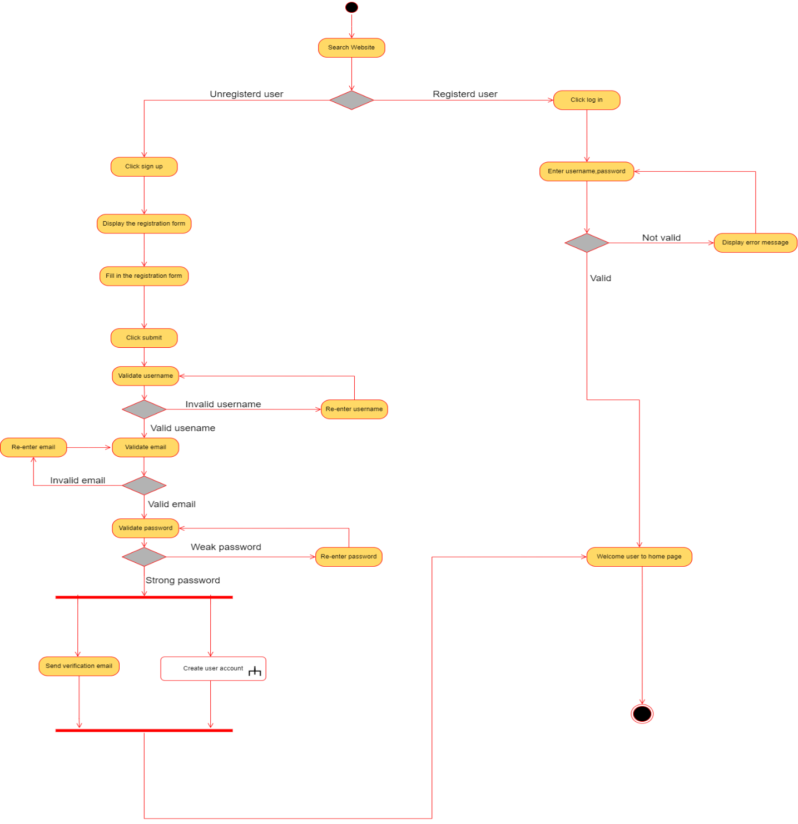

Part 01 – Call action

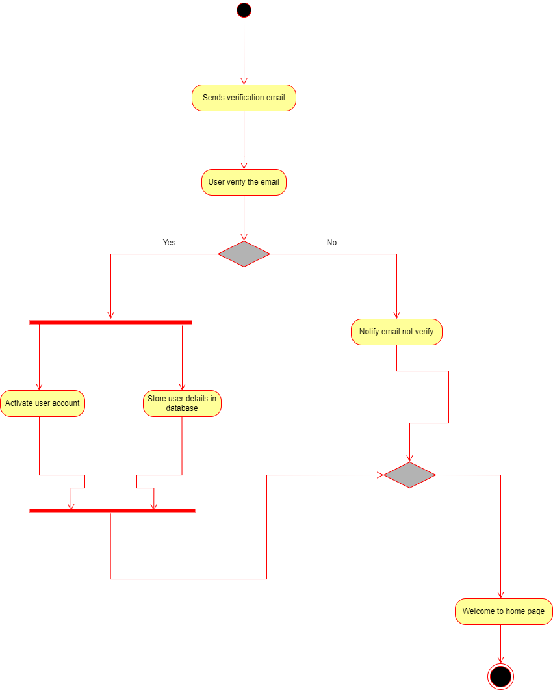

Part 02 – Sub system

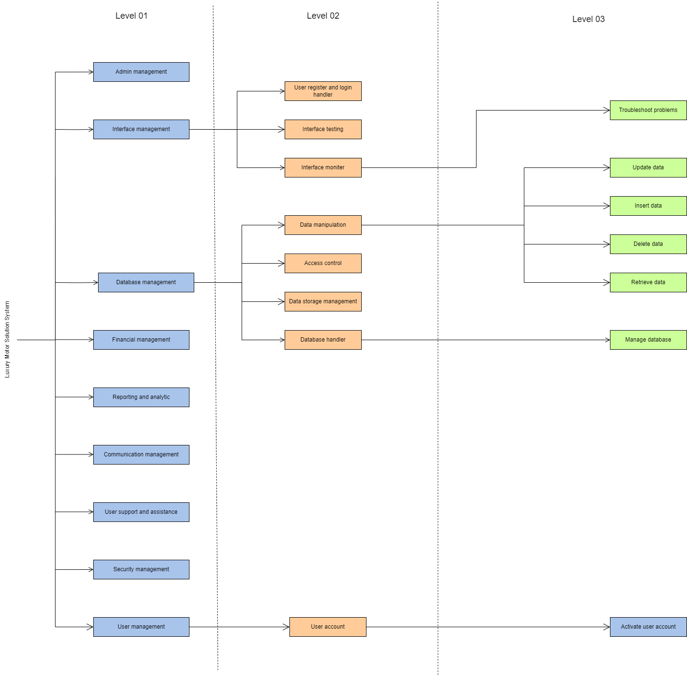

Part 02 – Activity diagram with partitioning

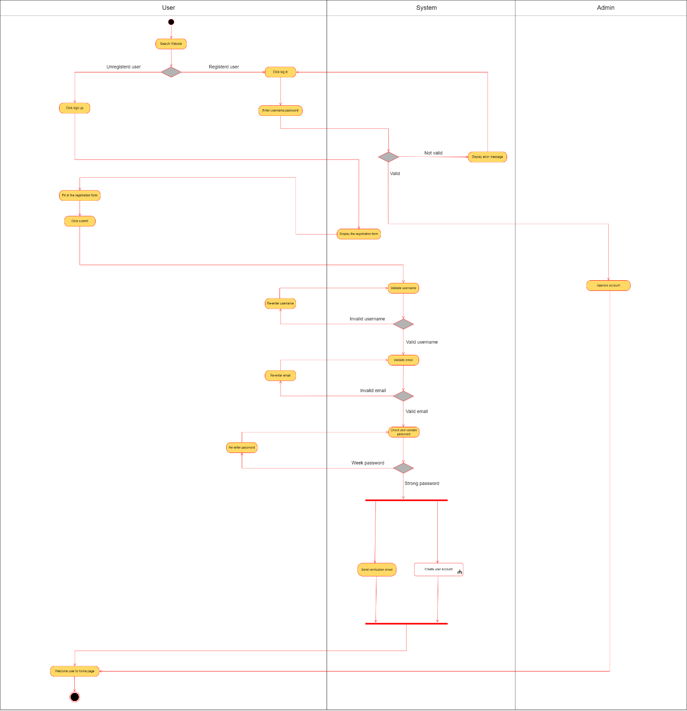

Assignment 2 Cover Sheet

CASE STUDY NAME | Online customer support system
PROJECT ID | MLB_04.02_07

Group Details:

 | Student Registration Number | Student Name
1 | IT23631410 | B G S H Dilshara
2 | IT23588714 | K H S Dinsara
3 | IT23775442 | T G C Theekshana
4 | IT23656574 | G H C R Saumya
5 | IT23637832 | D D Samaranayaka


BSc

(
Hons
)

in

Information

Technology

IT1060 – Software Process Modeling ^{February – 2024} September July - 2024-2023

Assignment 2 Certify Sheet
I

hereby

certify,

The

attached

is

my

own

work

and

no

further

changes

will

be

made.

I

have

contributed

in this assignment

to

the best

of

my ability.

And

I

understand,

I

may

be

subject

to

student

discipline

processes

in

the

event

of

an

act

of

academic

misconduct

by

me

including

an

act of

plagiarism

or

cheating.

Student Details:

Student Name | Student Registration Number | Date | Signature
T.G.C. THEEKSHANA | IT23775442 | 2024/10/04 | 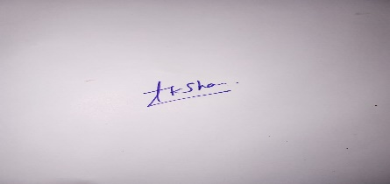

BSc

(
Hons
)

in

Information

Technology

IT23775442 - T.G.C. Theekshana gamage

Part 01 – Use Case Scenario

Use case ID | 04
Use case Name | Update user profile
Summary | Update user details.
Priority | 04
Pre-condition | User Account is Active
Post-condition | Profile information is update
Primary actor | Registered user
Trigger | Update personal details and manage user account.
Main scenario | Step | Action
 | (1) | Registered user Logs into the support system.
 | (2) | Registered user navigates to profile settings
 | (3) | Registered user initiates profile update.
 | (4) | Registered user updates profile information.
 | (5) | Registered user submits profile changes
 | (6) | System Validates and saves changes
 | (7) | Email Verification
 | (8) | System confirms profile update
 | (9) | Registered user receives Email Confirmation
 | (10) | Administrator logs or reviews changes.
Extensions | Step
 | (4a) | If user enter special characters for the username display error message.

Part 01 – Activity diagram
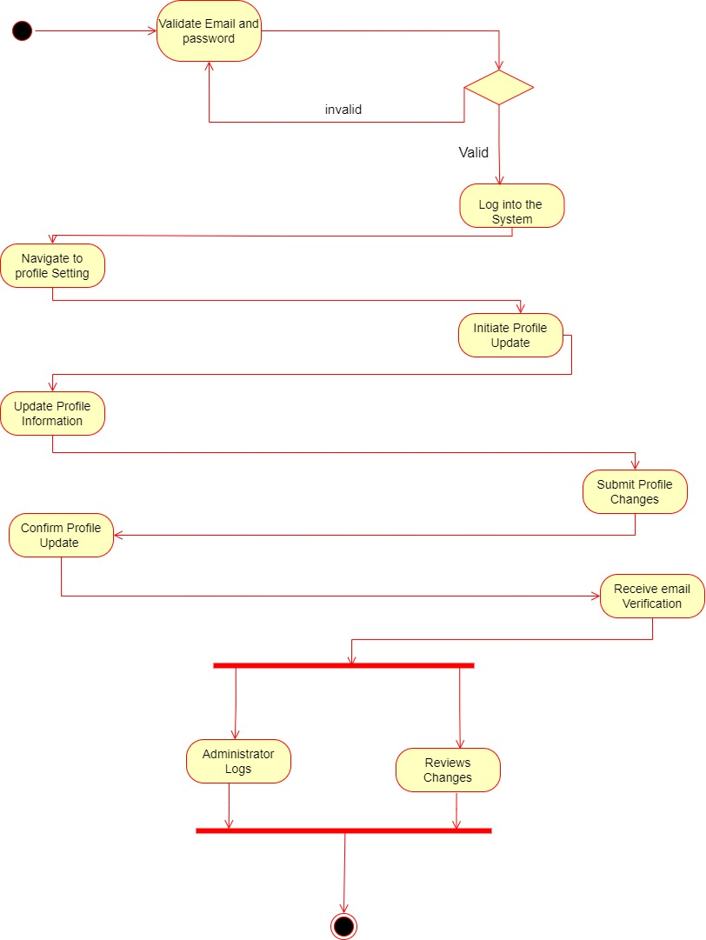

Part 02 – Sub system

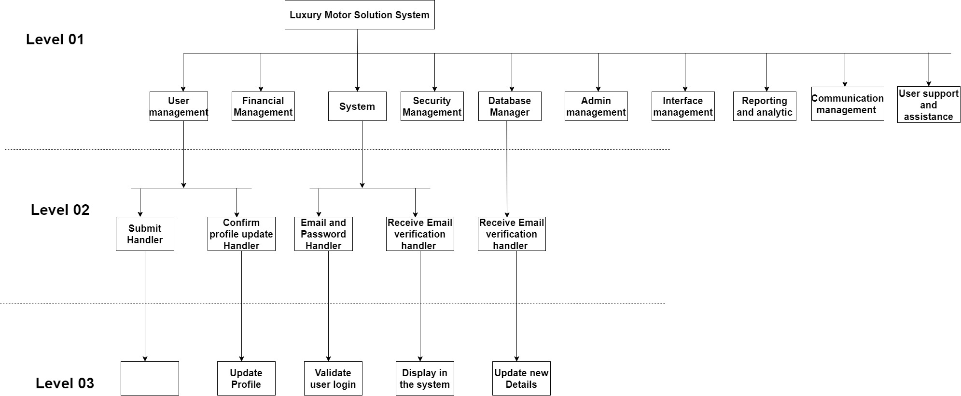

Part 02 – Activity diagram with partitioning

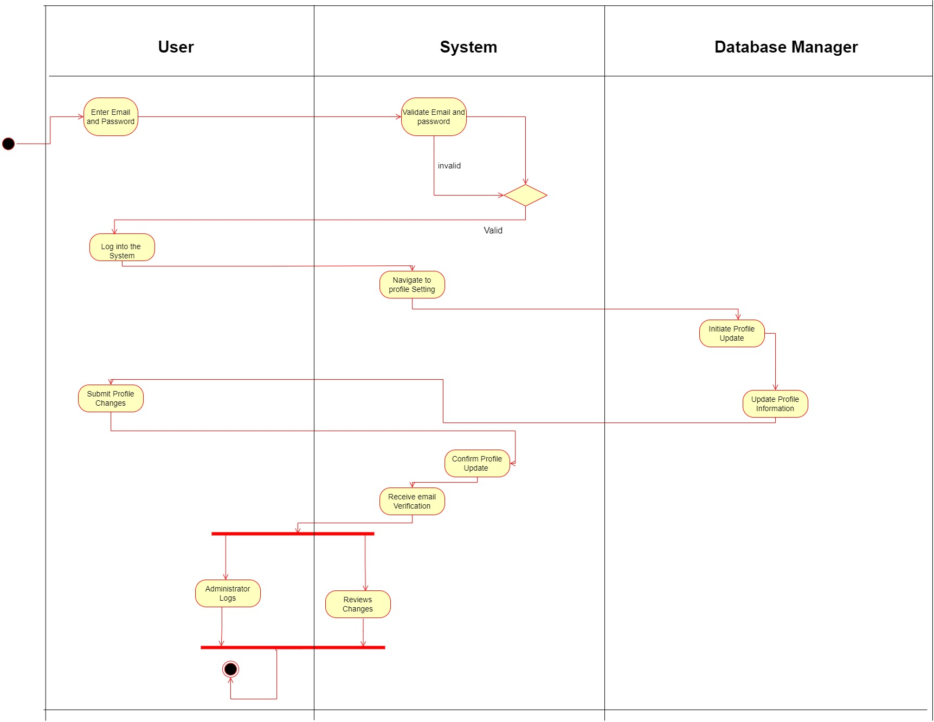

Assignment 2 Cover Sheet

CASE STUDY NAME | Online customer support system
PROJECT ID | MLB_04.02_07

Group Details:

 | Student Registration Number | Student Name
1 | IT23631410 | B G S H Dilshara
2 | IT23588714 | K H S Dinsara
3 | IT23775442 | T G C Theekshana
4 | IT23656574 | G H C R Saumya
5 | IT23637832 | D D Samaranayaka

Assignment 2 Certify Sheet
I

hereby

certify,

The

attached

is

my

own

work

and

no

further

changes

will

be

made.

I

have

contributed

in this assignment

to

the best

of

my ability.

And

I

understand,

I

may

be

subject

to

student

discipline

processes

in

the

event

of

an

act

of

academic

misconduct

by

me

including

an

act of

plagiarism

or

cheating.

Student Details:

Student Name | Student Registration Number | Date | Signature
D.T. Samaranayaka | IT23637832 | 2024-10-06 | 

IT23637832 - D.T. Samaranayaka

Part 01 – Use Case Scenario
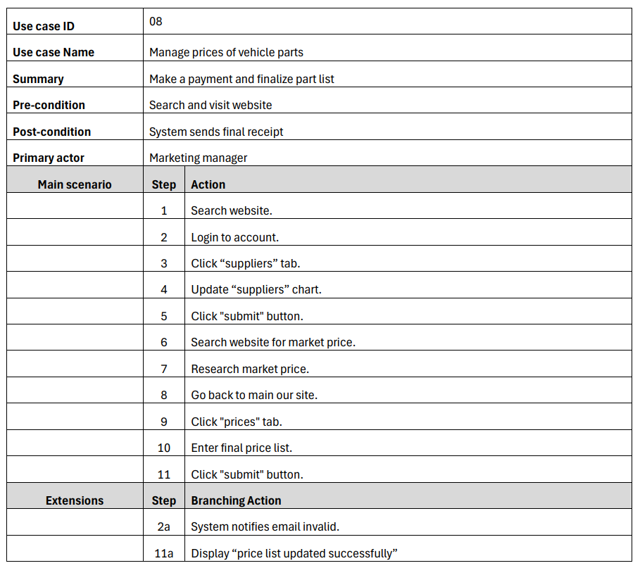

Part 01 – Activity diagram

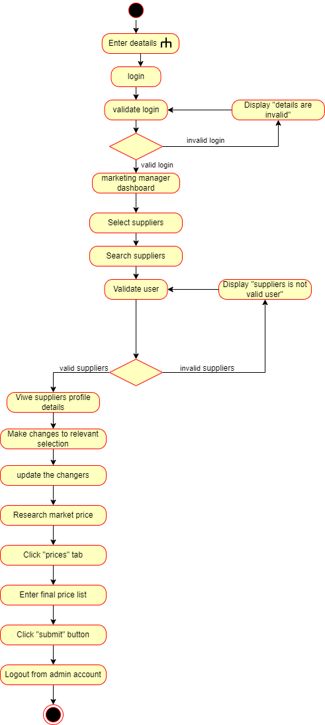

Part 01 – Call action

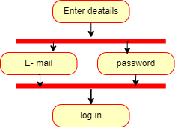

Part 02 – Sub system

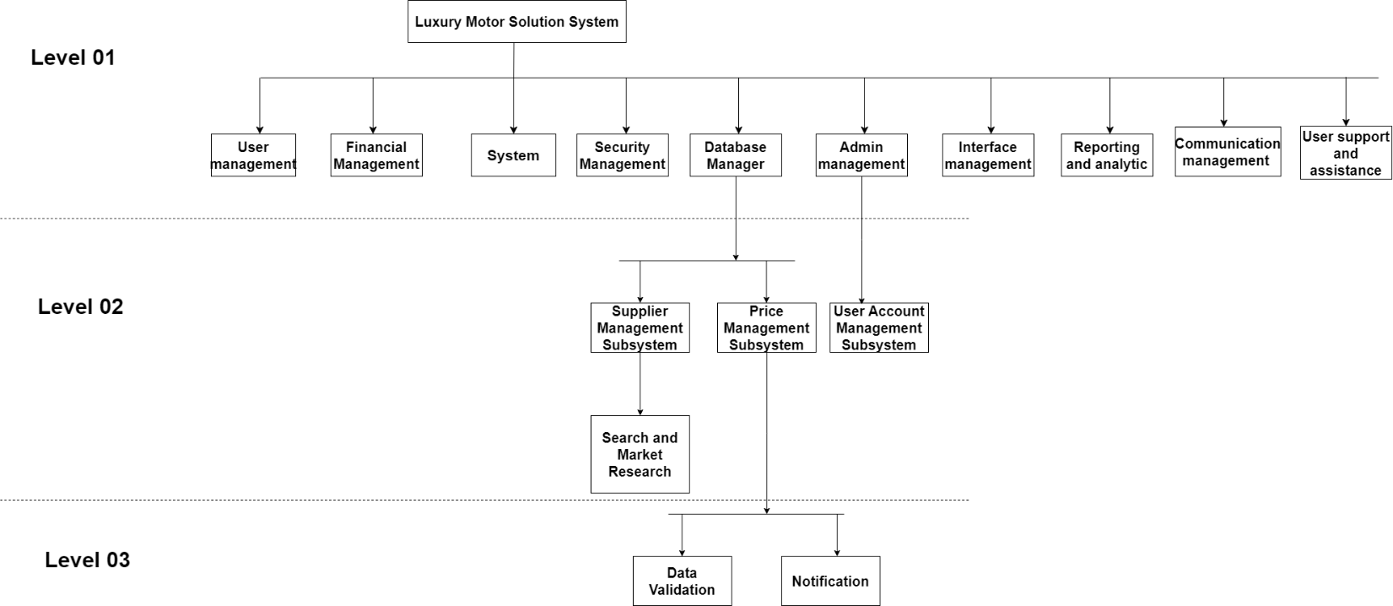

Part 02 – Activity diagram with partitioning

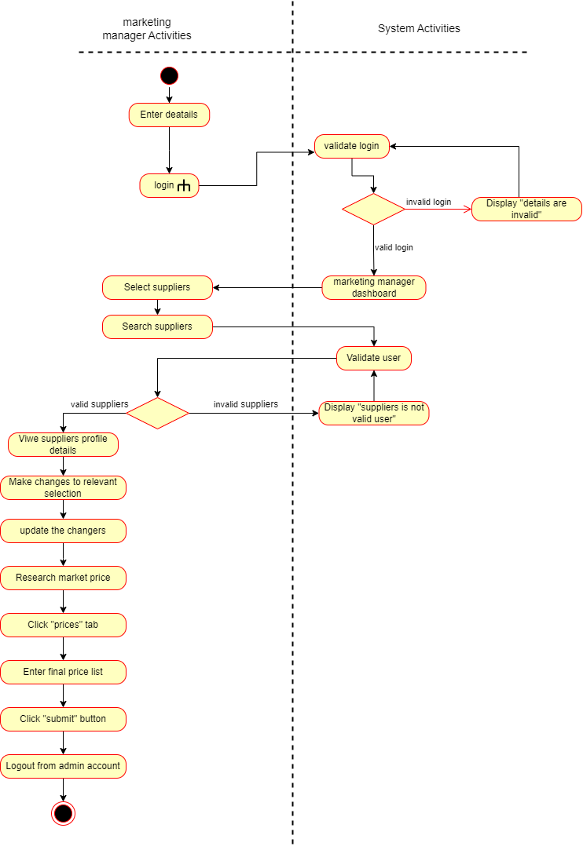

Assignment 2 Cover Sheet

CASE STUDY NAME | Online customer support system
PROJECT ID | MLB_04.02_07

Group Details:

 | Student Registration Number | Student Name
1 | IT23631410 | B G S H Dilshara
2 | IT23588714 | K H S Dinsara
3 | IT23775442 | T G C Theekshana
4 | IT23656574 | G H C R Saumya
5 | IT23637832 | D D Samaranayaka

Assignment 2 Certify Sheet
I

hereby

certify,

The

attached

is

my

own

work

and

no

further

changes

will

be

made.

I

have

contributed

in this assignment

to

the best

of

my ability.

And

I

understand,

I

may

be

subject

to

student

discipline

processes

in

the

event

of

an

act

of

academic

misconduct

by

me

including

an

act of

plagiarism

or

cheating.

Student Details:

Student Name | Student Registration Number | Date | Signature
B G S H Dilshara | IT23631410 | 2024-10-06 | 

IT23631410 - B G S H Dilshara

Part 01 – Use Case Scenario

Use case ID | 05
Use case name | Manage feedbacks
Summary | Admin overseas customer feedback and take relevant actions.
Priority | 04
Pre-condition | 1.Admin logins to the admin portal using admin credentials.  2.Reviewing customer feedback through system
Post condition | 1.Actions are taken against feedback.  2.Give note to users that the relevant feedback is noted and updated.
Primary actor(s) | Admin
Trigger | To Manage user feedback and take relevant actions.
Main success scenario: | Step | Actions
 | 1 | Admin logins using the admin portal.
 | 2 | From the admin dashboard choose feedback management.
 | 3 | Go through the list of customer feedback and choose the most important ones.
 | 4 | View the relevant feedback and view full details about the feedback.
 | 5 | Category the issue according to the relevant field type.
 | 6 | Provide the customer a comment mentioning the issue is under update or solved.
 | 7 | Pass the relevant feedback issues to the appropriate development fields.
 | 8 | From the feedback list mark whether the feedbacks are resolved or not.
 | 9 | Generate reports base on the feedback analyzed.
 | 10 | Logout of admin portal.
Extensions: | Step | Branching Actions
 | 1.a | Admin details are invalid. the system will display enter valid information.
 | 3.a | Alert higher parties if there is very important feedback.
 | 6.a | Ask the user to enter a rating regarding the feedback service.

Part 01 – Activity diagram

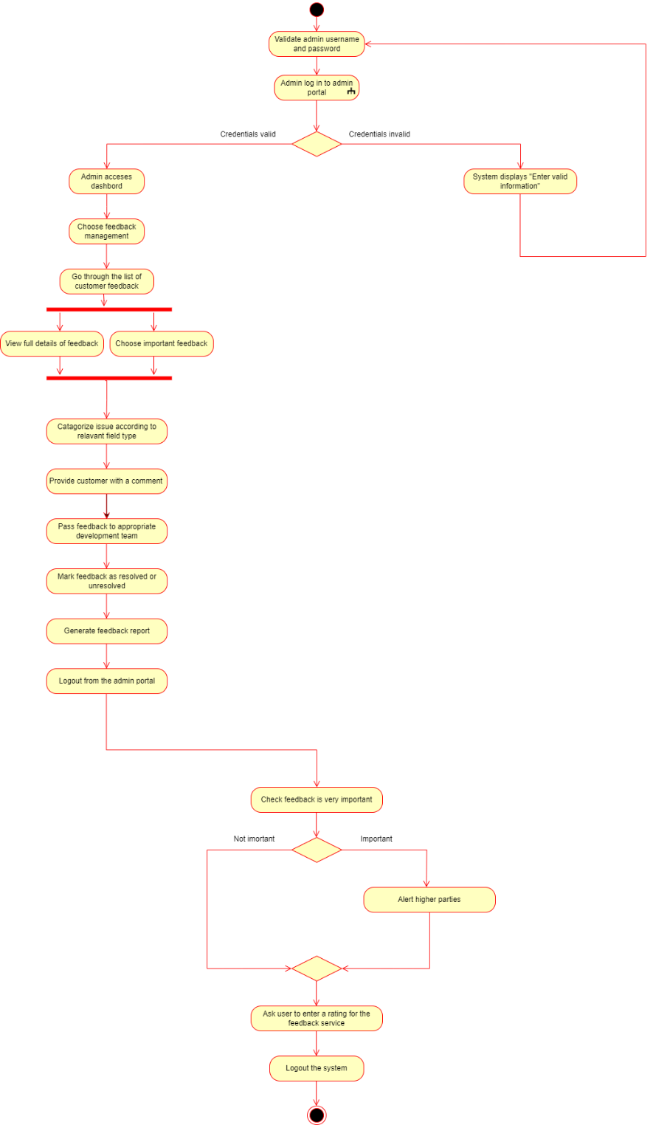

Part 01 – Call action

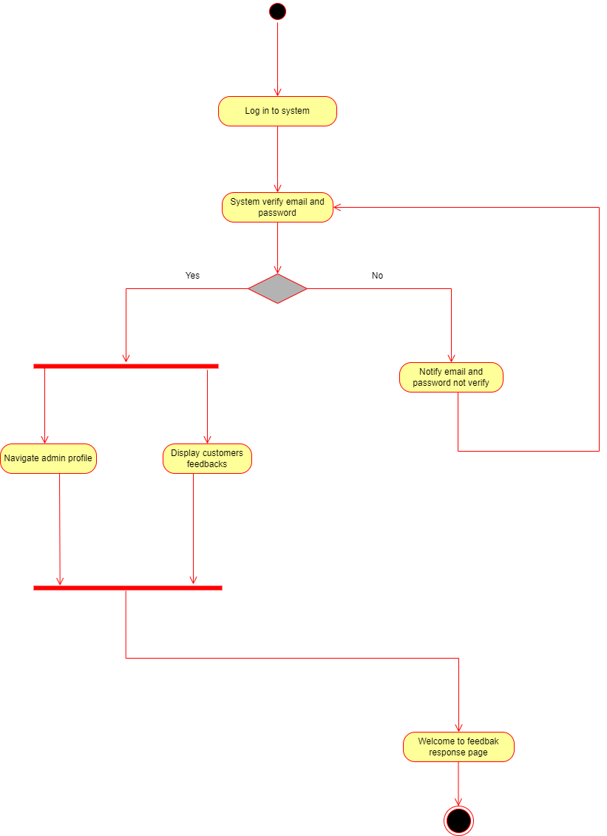

Part 02 – Sub system

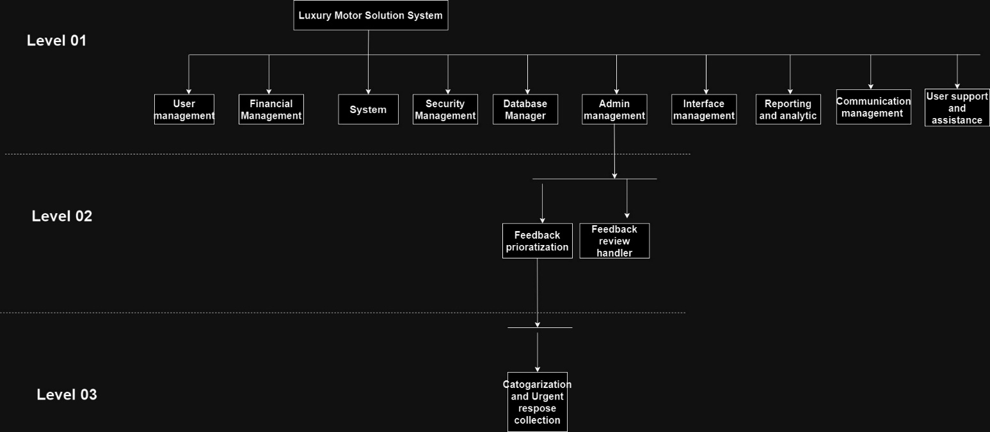

Part 02 – Activity diagram with partition

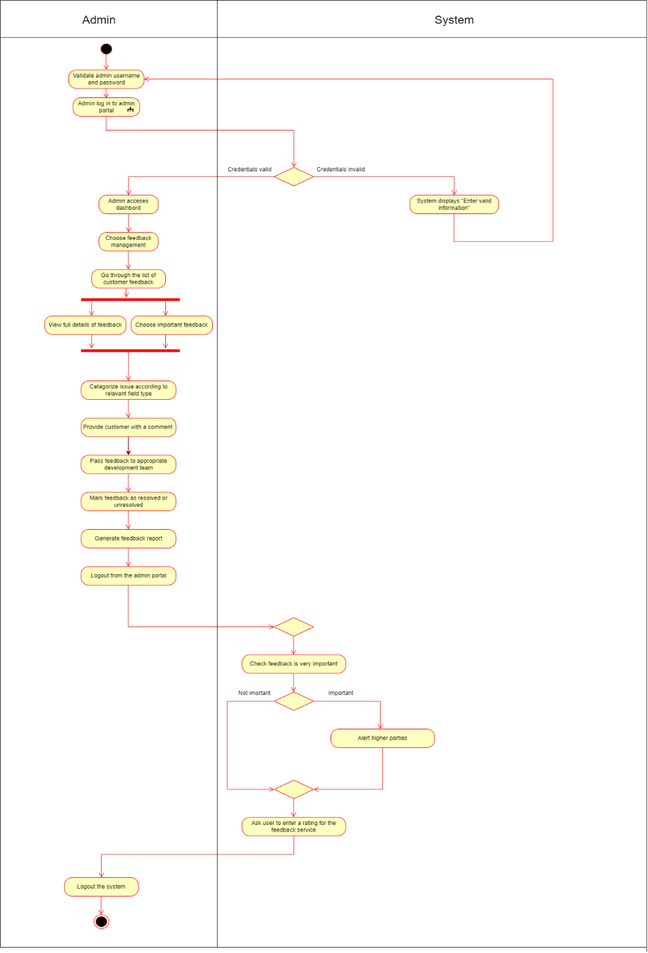

Assignment 2 Cover Sheet

Project ID | MLB_04.02_07
Case Study Name | Online Customer Support System
Campus / Center | Malabe

Group Details:

 | Student Registration Number | Student Name
1 | IT23631410 | B.G.S.H. Dilshara
2 | IT23588714 | K.H.S. Dinsara
3 | IT23775442 | T.G.C. Theekshana
4 | IT23656574 | G.H.C.R. Saumya
5 | IT23637832 | D.T. Samaranayaka

Assignment 2 Certify Sheet
I

hereby

certify,

The

attached

is

my

own

work

and

no

further

changes

will

be

made.

I

have

contributed

in this assignment

to

the best

of

my ability.

And

I

understand,

I

may

be

subject

to

student

discipline

processes

in

the

event

of

an

act

of

academic

misconduct

by

me

including

an

act of

plagiarism

or

cheating.

Student Details:

Student Name | Student Registration Number | Date | Signature
G.H.C.R.Samya | IT23656774 | 2024-10-06 | 

1.Use Case Scenario

Use case ID | 09
Use case name | Give user relevant information
Summary | Enhances user experience by offering quick and relevant information.
Priority | 01
Pre-condition | The user has accessed the chat assistant feature on the online luxury motor solutions platform.
Post condition | The user receives accurate and relevant information in response to their query.
Primary actor(s) | Chat assistent
Trigger | Troubleshooting Help
Main success scenario: | Step | Actions
 | 1 | Visit the website.
 | 2 | Providing Vehicle Maintenance Tips
 | 3 | Answering Frequently Asked Questions
 | 4 | Offering Step-by-Step Troubleshooting Guides
 | 5 | Providing Information on Nearest Service Centers
 | 6 | Assisting with Booking Service Appointments
 | 7 | Providing Updates on Service Status
 | 8 | Explaining Warranty and Coverage Information
 | 9 | Providing Recall Information
 | 10 | Assisting with Account or Profile Updates
Extensions: | Step | Branching Actions
 | 1a | Information Not Available or Out of Scope
 | 1b | Technical Issues or Service Interruptions

2.Activity Diagram without partitioning

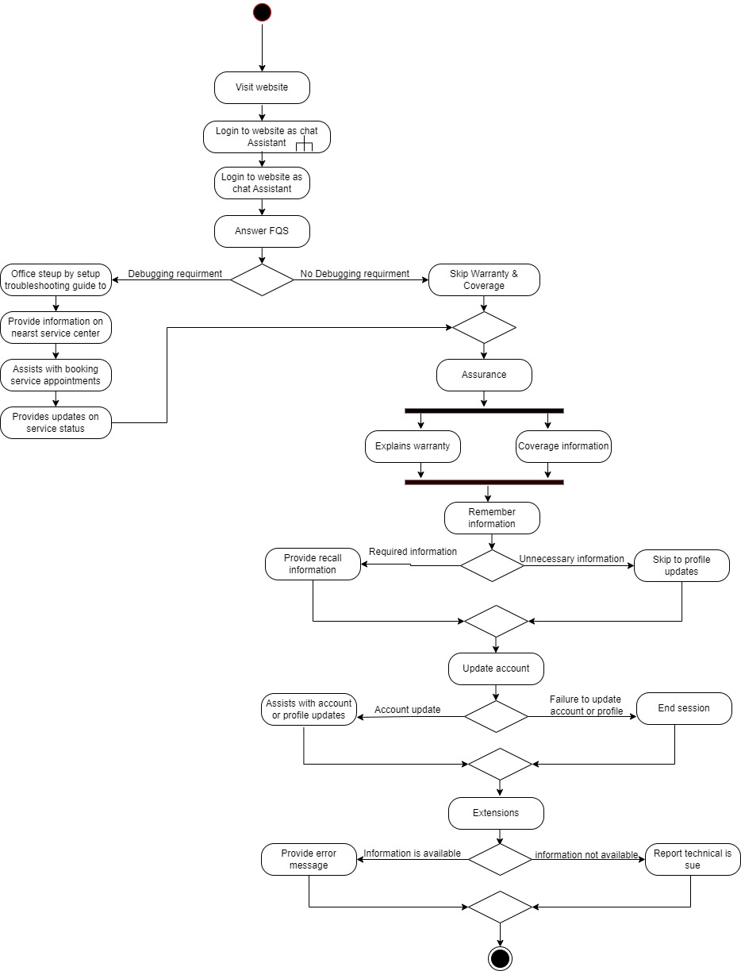

3.Call Action
- Login to website as Chat Assistant

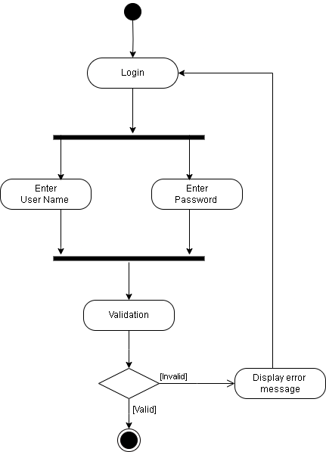

3. Sub-Systems

